**Министерство науки и высшего образования Российской Федерации Федеральное государственное бюджетное образовательное учреждение высшего образования** 

**«Московский государственный технический университет**

**имени Н.Э. Баумана**

**(национальный исследовательский университет)»**

**(МГТУ им. Н.Э. Баумана)**

**Факультет «Информатика и системы управления»**

**Кафедра ИУ5 «Системы обработки информации и управления»**

Отчет по лабораторной работе №1

по дисциплине «Методы машинного обучения»

по теме «Создание “истории о данных”»

Выполнил:

студент группы № ИУ5-24М

Никитина К. В.

подпись, дата

Проверил:

подпись, дата

2024 г.

**Задание.**

Создать "историю о данных" в виде юпитер-ноутбука, с учетом следующих требований:

1. История должна содержать не менее 5 шагов (где 5 - рекомендуемое количество шагов). Каждый шаг содержит график и его текстовую

интерпретацию.

2. На каждом шаге наряду с удачным итоговым графиком рекомендуется в юпитер-ноутбуке оставлять результаты предварительных "неудачных" графиков.

3. Не рекомендуется повторять виды графиков, желательно создать 5 графиков различных видов.

4. Выбор графиков должен быть обоснован использованием методологии data-to-viz. Рекомендуется учитывать типичные ошибки построения выбранного вида графика по методологии data-to-viz. Если методология Вами отвергается, то просьба обосновать Ваше решение по выбору графика.

5. История должна содержать итоговые выводы. В реальных "историях о данных" именно эти выводы представляют собой основную ценность для предприятия.

**Лабраторная работа №1. Создание "истории о данных".**

**Загрузка необходимых библиотек.**

**import** numpy **as** np

**import** pandas **as** pd

**import** seaborn **as** sns

**import** matplotlib.pyplot **as** plt

%matplotlib inline

sns.set(style="ticks")

**Описание набора данных. Загрузка данных.**

**Context** Dataset of Starcraft 2 games, played in different leagues/levels.

**Content** Screen movements aggregated into screen-fixations. -- Time is recorded in terms of timestamps in the StarCraft 2 replay file. When the game is played on 'faster', 1 real-time second is equivalent to roughly 88.5 timestamps.

**Attribute Information:**

*GameID:* Unique ID number for each game (integer)

*LeagueIndex:* Bronze, Silver, Gold, Platinum, Diamond, Master, GrandMaster, and Professional leagues coded 1-8 (Ordinal)

*Age:* Age of each player (integer)

*HoursPerWeek:* Reported hours spent playing per week (integer)

*TotalHours:* Reported total hours spent playing (integer)

*APM:* Action per minute (continuous)

*SelectByHotkeys:* Number of unit or building selections made using hotkeys per timestamp (continuous)

*AssignToHotkeys:* Number of units or buildings assigned to hotkeys per timestamp (continuous)

*UniqueHotkeys:* Number of unique hotkeys used per timestamp (continuous) *MinimapAttacks:* Number of attack actions on minimap per timestamp (continuous) *MinimapRightClicks:* number of right-clicks on minimap per timestamp (continuous) *NumberOfPACs:* Number of PACs per timestamp (continuous)

*GapBetweenPACs:* Mean duration in milliseconds between PACs (continuous)

*ActionLatency:* Mean latency from the onset of a PACs to their first action in milliseconds (continuous)

*ActionsInPAC:* Mean number of actions within each PAC (continuous)

*TotalMapExplored:* The number of 24x24 game coordinate grids viewed by the player per timestamp (continuous)

*WorkersMade:* Number of SCVs, drones, and probes trained per timestamp (continuous) *UniqueUnitsMade:* Unique unites made per timestamp (continuous)

*ComplexUnitsMade:* Number of ghosts, infestors, and high templars trained per timestamp (continuous)

*ComplexAbilitiesUsed:* Abilities requiring specific targeting instructions used per timestamp (continuous)

data = pd.read_csv('starcraft_player_data.csv', sep=",") *# Первые 5 строк датасета*

data = data.drop(['GameID'], axis=1)

data.head()

LeagueIndex Age HoursPerWeek TotalHours APM SelectByHotkeys \

0 5 27 10 3000 143.7180 0.003515 1 5 23 10 5000 129.2322 0.003304 2 4 30 10 200 69.9612 0.001101 3 3 19 20 400 107.6016 0.001034 4 3 32 10 500 122.8908 0.001136

AssignToHotkeys UniqueHotkeys MinimapAttacks MinimapRightClicks \

0 0.000220 7 0.000110 0.000392 1 0.000259 4 0.000294 0.000432 2 0.000336 4 0.000294 0.000461 3 0.000213 1 0.000053 0.000543 4 0.000327 2 0.000000 0.001329

NumberOfPACs GapBetweenPACs ActionLatency ActionsInPAC \ 0 0.004849 32.6677 40.8673 4.7508 1 0.004307 32.9194 42.3454 4.8434 2 0.002926 44.6475 75.3548 4.0430

3 0.003783 29.2203 53.7352 4.9155 4 0.002368 22.6885 62.0813 9.3740

TotalMapExplored WorkersMade UniqueUnitsMade ComplexUnitsMade \ 0 28 0.001397 6 0.0 1 22 0.001194 5 0.0 2 22 0.000745 6 0.0 3 19 0.000426 7 0.0 4 15 0.001174 4 0.0

ComplexAbilitiesUsed

0 0.000000

1 0.000208

2 0.000189

3 0.000384

4 0.000019

data.dtypes

LeagueIndex int64

Age object

HoursPerWeek object

TotalHours object

APM float64

SelectByHotkeys float64

AssignToHotkeys float64

UniqueHotkeys int64

MinimapAttacks float64

MinimapRightClicks float64

NumberOfPACs float64

GapBetweenPACs float64

ActionLatency float64

ActionsInPAC float64

TotalMapExplored int64

WorkersMade float64

UniqueUnitsMade int64

ComplexUnitsMade float64

ComplexAbilitiesUsed float64

dtype: object

plt.figure(figsize=(6,6))

plt.pie(data['LeagueIndex'].value_counts(),labels=['Bronze', 'Silver', 'Gold', 'Platinum', 'Diamond', 'Master', 'GrandMaster', 'Professional'], autopct='%1.1f%%')

([<matplotlib.patches.Wedge at 0x1c464144580>,

<matplotlib.patches.Wedge at 0x1c464144c70>,

<matplotlib.patches.Wedge at 0x1c4643a8340>,

<matplotlib.patches.Wedge at 0x1c4643a89d0>,

<matplotlib.patches.Wedge at 0x1c4643b50a0>,

<matplotlib.patches.Wedge at 0x1c4643b5730>,

<matplotlib.patches.Wedge at 0x1c4643b5dc0>,

<matplotlib.patches.Wedge at 0x1c4643c2490>],

[Text(0.8045083504569398, 0.7501775216874028, 'Bronze'), Text(-0.6882236115228018, 0.8581073712202407, 'Silver'), Text(-1.0018407647429992, -0.45421920049593084, 'Gold'), Text(-0.06459903035833876, -1.0981015277636046, 'Platinum'), Text(0.7689506830637547, -0.7865842911066717, 'Diamond'), Text(1.0437779190648944, -0.3471709314913321, 'Master'), Text(1.0926494802731535, -0.12695319318082604, 'GrandMaster'), Text(1.0994231286952005, -0.03561999564930912, 'Professional')], [Text(0.4388227366128762, 0.40918773910221967, '23.9%'), Text(-0.37539469719425544, 0.4680585661201312, '23.7%'), Text(-0.5464585989507268, -0.24775592754323497, '18.3%'), Text(-0.03523583474091205, -0.5989644696892388, '16.3%'), Text(0.4194276453075025, -0.4290459769672754, '10.2%'), Text(0.5693334103990332, -0.18936596263163566, '4.9%'), Text(0.5959906256035381, -0.06924719628045056, '1.6%'), Text(0.5996853429246547, -0.019429088535986794, '1.0%')])

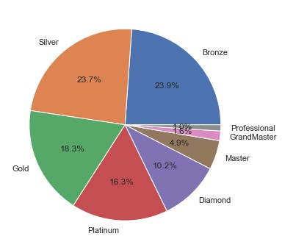

mean = 0

count = 0

**for** i **in** range(len(data['HoursPerWeek'])):

**if** (data['HoursPerWeek'][i] !='?'):

mean+=int(data['HoursPerWeek'][i])

count+=1

mean=mean/count

print(mean)

**for** i **in** range(len(data['HoursPerWeek'])):

**try**:

data['HoursPerWeek'][i]= int(data['HoursPerWeek'][i]) **except**: data['HoursPerWeek'][i]=mean

*#print(data['HoursPerWeek'])*

sns.distplot(data['HoursPerWeek'])

15.910751722072478

<ipython-input-5-8b6b9db67a72>:11: SettingWithCopyWarning: A value is trying to be set on a copy of a slice from a DataFrame

See the caveats in the documentation:

https://pandas.pydata.org/pandas-docs/stable/user_guide/indexing.html# returning-a-view-versus-a-copy

data['HoursPerWeek'][i]= int(data['HoursPerWeek'][i]) <ipython-input-5-8b6b9db67a72>:12: SettingWithCopyWarning: A value is trying to be set on a copy of a slice from a DataFrame

See the caveats in the documentation:

https://pandas.pydata.org/pandas-docs/stable/user_guide/indexing.html# returning-a-view-versus-a-copy

except: data['HoursPerWeek'][i]=mean

C:\Users\User\anaconda3\lib\site-packages\seaborn\

distributions.py:2551: FutureWarning: `distplot` is a deprecated function and will be removed in a future version. Please adapt your code to use either `displot` (a figure-level function with similar flexibility) or `histplot` (an axes-level function for histograms). warnings.warn(msg, FutureWarning)

<AxesSubplot:xlabel='HoursPerWeek', ylabel='Density'>

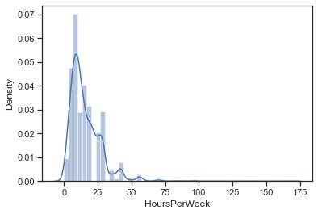sns.boxplot(x=data['UniqueUnitsMade'])

<AxesSubplot:xlabel='UniqueUnitsMade'>

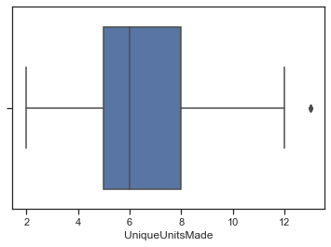

labels=['Bronze', 'Silver', 'Gold', 'Platinum', 'Diamond', 'Master', 'GrandMaster', 'Professional']

**for** i **in** range(len(data['LeagueIndex'])):

data['LeagueIndex'][i]=labels[data['LeagueIndex'][i]-1]

sns.kdeplot(data=data, x="APM", hue="LeagueIndex",

hue_order=labels,cut=0, fill=True, common_norm=False, alpha=0.4)

<ipython-input-7-743ad4758516>:3: SettingWithCopyWarning: A value is trying to be set on a copy of a slice from a DataFrame

See the caveats in the documentation:

https://pandas.pydata.org/pandas-docs/stable/user_guide/indexing.html# returning-a-view-versus-a-copy

data['LeagueIndex'][i]=labels[data['LeagueIndex'][i]-1] C:\Users\User\anaconda3\lib\site-packages\pandas\core\indexing.py:670: SettingWithCopyWarning:

A value is trying to be set on a copy of a slice from a DataFrame

See the caveats in the documentation:

https://pandas.pydata.org/pandas-docs/stable/user_guide/indexing.html# returning-a-view-versus-a-copy

iloc._setitem_with_indexer(indexer, value)

<AxesSubplot:xlabel='APM', ylabel='Density'>

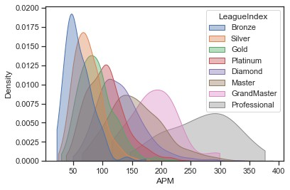

fig, axes = plt.subplots(figsize = (15, 10))

sns.countplot(x = 'UniqueUnitsMade', data = data, palette="Set2"); fig, axes = plt.subplots(figsize = (20, 12))

sns.countplot(x = 'UniqueUnitsMade', hue="LeagueIndex", hue_order=labels, data = data, palette="Set2");

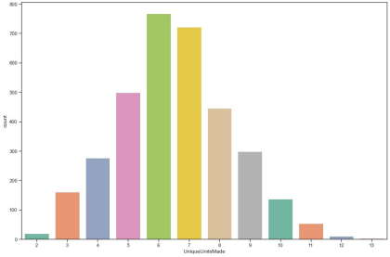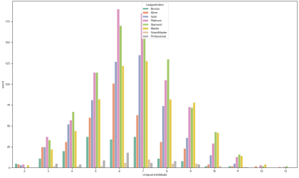

fig, axes = plt.subplots(figsize = (15, 10))

sns.countplot(x = 'UniqueHotkeys', data = data, palette="Set2"); fig, axes = plt.subplots(figsize = (20, 12))

sns.countplot(x = 'UniqueHotkeys', hue="LeagueIndex", hue_order=labels, data = data, palette="Set2");

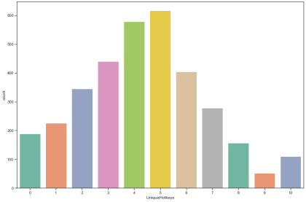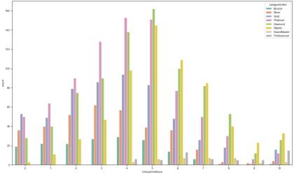

**import** numpy **as** np

**import** matplotlib.pyplot **as** plt

FLIPPER_LENGTH = data["NumberOfPACs"].values

BILL_LENGTH = data["APM"].values

SPECIES = data["LeagueIndex"].values

SPECIES_ = np.unique(SPECIES)

COLORS = ["#ff0000", "#ffa500", "#ffff00", "#008000", "#0000ff", "#4b0082", "#ee82ee" ]

fig, ax = plt.subplots(figsize=(8,8))

**for** species, color **in** zip(SPECIES_, COLORS):

idxs = np.where(SPECIES == species)

*# No legend will be generated if we don't pass label=species* ax.scatter(

FLIPPER_LENGTH[idxs], BILL_LENGTH[idxs], label=species, s=50, color=color, alpha=0.7

)

ax.legend();

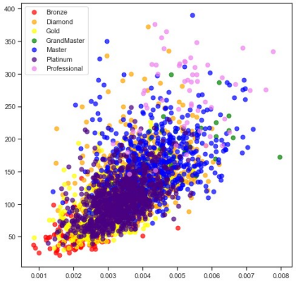corr_matrix = data.corr()

sns.heatmap(data.corr(), annot=True)

sns.set(rc = {'figure.figsize':(30,30)})

